**KATHMANDU UNIVERSITY**

SCHOOL OF ENGINEERING

**DEPARTMENT OF COMPUTER SCIENCE & ENGINEERING**

**PROJECT REPORT**



**“My Virtual Classroom”**

A **Third year/ Second Semester** Combined Engineering Project [COMP 308]

Report submitted in partial fulfilment of the requirements

for the degree of Bachelor of Engineering.

**By:**

Prashant Bhatta (09)

Bishal KC (22)

Ashish Pokhrel (38)

Dinesh Poudel (39)

**Supervised By:**

Mr. Sushil Shrestha

Assistant Professor

Department of Computer Science and Engineering

**September 2020**

**Bonafide Certificate**

**This project work on**

**“My Virtual Classroom”**

**is the bonafide work of**

**Prashant Bhatta (09)**

**Bishal KC (22)**

**Ashish Pokhrel (38)**

**Dinesh Poudel (39)**

**who carried out the project work under my supervision.**

**Project Supervisor**

**Mr. Sushil Shrestha**

Assistant Professor

# ABSTRACT

The pandemic resulted the shifting of the education system into a virtual one. Schools, colleges and university started to adapt the virtual classroom idea to cope with the ongoing situation. This resulted huge amount of problems for the students and teachers as shifting into a completely new technology is somehow a difficult job. The new way of attending the classes and performing the class activities are being a burden for many students. Alongside this, the use of poorly designed and structured learning management system certainly adds more problems. Keeping this in mind we developed “My Virtual Classroom” which makes sure attending and presenting classes in virtual environment is brings no hassle to students and teacher.

“My Virtual Classroom” is an educational video conferencing web-based application for online study. Being video conferencing its main feature, it also contains all the resources provided by the teachers. Teachers can leave the assignments or tasks in the assignment portal allocating the due date where students are able to submit their work. To make it more engaging we added chat box in the video conference We made this application as natural as it might seem to the students. So, we designed the user interface keeping a classroom in mind as we want to replicate the classroom, its teachings and learning but in virtual manner. Through this application student don’t face the hassle of finding the video chat link which is changed every day. Our application made them feel as they are visiting a classroom on daily basis through their home computers. The best thing about this application is its flexibility. Students are able to enroll in multiple courses as they desire, and teachers are able to create multiple courses and customize it according to their need.

**Keywords:** Video Conferencing, Virtual Classroom, Online Study, Classroom

Management, Classroom Environment, Student Portal, Teacher Portal etc.

ACKNOWLEDGEMENT

A special thanks to the Department of Computer Science and Engineering as well as the project coordinator Dr. Gajendra Sharma. We would also like to thank our project supervisor, Mr. Sushil Shrestha, whose constant supervision helped us for the successful completion of the project.

This project would not have been possible without the help of seniors and lab assistants who helped us in the project directly and indirectly.

# LIST OF ILLUSTRATIONS

Figure 2.1 Canvas.....................................................................................................................3

Figure 2.2 Blackboard..............................................................................................................4

Figure 2.3 Google Classroom...................................................................................................5

Figure 3.1 Flow Diagram..........................................................................................................6

Figure 3.2 ER Diagram.............................................................................................................7

Figure 3.3 Use-Case Diagram...................................................................................................8

Figure 3.4 Survey Chart 1.........................................................................................................9

Figure 3.5 Survey Chart 2.......................................................................................................10

Figure 3.6 Survey Chart 3.......................................................................................................10

Figure 3.7 Survey Chart 4.......................................................................................................11

Figure 3.8 Paper prototype for student and teacher................................................................12

Figure 3.9 Paper prototype for landing page of LMS.............................................................13

Figure 5.1 Project Interface.....................................................................................................19

Figure 5.2 Video Conferencing feature...................................................................................20

Figure 5.3 Course Instructions................................................................................................21

# ABBREVIATIONS USED

|  |  |
| --- | --- |
| **Abbreviations** | **Full Form** |
| WebRTC | Web Real-Time Communication |
| SSPL | Server-Side Programming Language |
| W3C | World Wide Web Consortium |
| IETF | Internet Engineering Task Force |

# TABLE OF CONTENTS

ABSTRACT ii

LIST OF ILLUSTRATIONS iv

ABBREVIATIONS USED v

TABLE OF CONTENTS vi

CHAPTER 1 1

INTRODUCTION 1

1.1 Background 1

1.2 Objectives 2

1.3 Motivation 2

1.3 Significances 2

CHAPTER 2 3

LITERATURE REVIEW 3

CHAPTER 3 6

METHODOLOGY 6

Design and Implementation 6

3.1 Flow Diagram 6

3.2 ER Diagram 7

3.3 Use-case Diagram 8

3.4 Procedure 9

3.4.1 Survey 9

3.4.2 Paper Prototype 12

3.4.3 Norman’s 7 principles 14

3.4.4 Schneiderman’s 8 Golden Rules 14

3.4.5 Heuristic evaluation 14

3.4.6 Final Usability Testing 15

CHAPTER 4 16

SYSTEM REQUIREMENT SPECIFICATIONS 16

4.1 Software Requirements 16

4.1.1 Visual Studio Code 16

4.1.2 Google Chrome 16

4.1.4 Front End Tools 16

4.1.5 Back End Tools 17

4.2 Hardware Requirements 18

CHAPTER 5 19

RESULTS, CONCLUSION AND FUTURE ENHANCEMENT 19

5.1 Results 19

5.2 Conclusion 22

5.3 Limitations 22

5.4 Future Enhancements 22

BIBLIOGRAPHY 23

APPENDIX (GANTT CHART) 24

# CHAPTER 1

# INTRODUCTION

## 1.1 Background

While countries are at different points in their COVID-19 infection rates, worldwide there are

currently more than 1.2 billion children in 186 countries affected by school closures due to the pandemic. With this sudden shift away from the classroom in many parts of the globe, some are wondering whether the adoption of online learning will continue to persist post-pandemic, and how such a shift would impact the worldwide education market.

Virtual classrooms and distance learning, as alternate technology-driven learning methods,

have been growing at a reasonable pace. Virtual classrooms have been specifically in use by

all sectors, including primary and higher education as well as corporate learning. The

increasing popularity of social and microlearning strategies, fostered by general social media

platforms like YouTube and Twitter, and major educational technology disruptions like edX,

have added to the increasing acceptance of virtual modes of learning. It is expected that the

predominant use of virtual classrooms would increase by a whopping 16.2% compounded

annual growth rate by 2023.

The current pandemic situation has paved the way for a ground test of virtual classrooms as a

prominent tool of learning in the current times. Schools, colleges, universities, corporates, and even world bodies and multilateral organizations like the UNO, WHO, and G20 have had to switch to the lesser-used virtual mode of learning and communications. These emergent

circumstances stand as a conducive test for companies offering virtual classroom platforms

and services like Blackboard, Desire2Learn, Cisco, Microsoft, etc. The test parameters are

varied, some predominant ones being bandwidth management, network traffic, server response time, and several concurrent users. Some of the existing virtual classroom are skooly.com, U-LMS, VEDAMO.com, Braincert.com, tutorrrom.net, newrow.com, etc.

“My Virtual Classroom” is an educational video conferencing web-based application for online study of various courses in colleges and Universities. It contains all the resources provided by the teachers, assignments along with their due dates. All the video conference was recorded and made available to the students as soon as the lecture ends. This web-app contains some additional features like chat-box during video conferencing and drawing tool for the tutor. Through this virtual classroom we made them feel as they are visiting a classroom on daily basis through their home computers.

## Objectives

The project has multiple purposes. Some of its key objectives are:

### To get personalized learning: Students can learn at their own time and phase by watching the recorded lecture videos at their own time,

### To have real-time teaching and learning by creating real time chat system during the video conference,

### To have equal access to everyone from anywhere and at any time,

### To encourages digital and smart classrooms by adding discussion forum, using survey to meet the stakeholders demand and using color psychology

### To enhance collaboration and communication between students and teachers by introducing features like real time chatting for synchronous and discussion forum for asynchronous mode.

## 1.3 Motivation

Education may have several purposes, and online learning helps to fulfill it. In today’s

technical world, going online instead of the traditional approach of attending the class, has started to become a trend. Significant rise in use of online learning due to ongoing pandemic has caught the eye of the entire world. Universities, colleges and even schools are starting to adopt the online teaching learning activities. Many universities are considering going online for the full semester. Increasing number of online learning activities, welcomes the same amount of problems for students and teachers, as shifting from a long time followed habit takes some time to adopt. Both teacher and student found it difficult to surf through poorly designed and structured online education platforms. Also, some platforms required payments to utilize its resource. All of these are the common situations we all faced, and it inspired us to design a new e-learning platform where user interaction is made simple and efficient.

## Significances

With a fully equipped LMS i.e., My Virtual Classroom, one can easily create courses for the students, add assessment and lecture slides, upload lecture videos and many more within a single platform. An eye-catching user interface will surely make a great difference and make learning more fun and interesting. For the proper interaction between the students, the discussion forum is there where one can put their query and seek help from other students as well as teachers. It is moreover handy and efficient to use.

# CHAPTER 2

# LITERATURE REVIEW

A virtual classroom is a synchronous learning environment in which students (customers, partners, or any third-party) engage with the lesson material online. Information is often conveyed through voice or video conferencing with several participants and instructors connected to the same chat interface. Virtual classrooms may come as an integrated part of a learning management system (LMS) or integrate with one. Some of the virtual classroom’s platforms are Zoom, Google Meet, Adobe Connect, Top Hat, Tutor Room and so on.

**Canvas** is one of the wide popular LMS but the color combination and font are not quite pleasing to users. Their dash boards are quite messy and it is hard to navigate. They have different dedicated webpages for assignment portal, video conference, course material and it makes the ecosystem more complex. Canvas doesn’t support discussion forum.

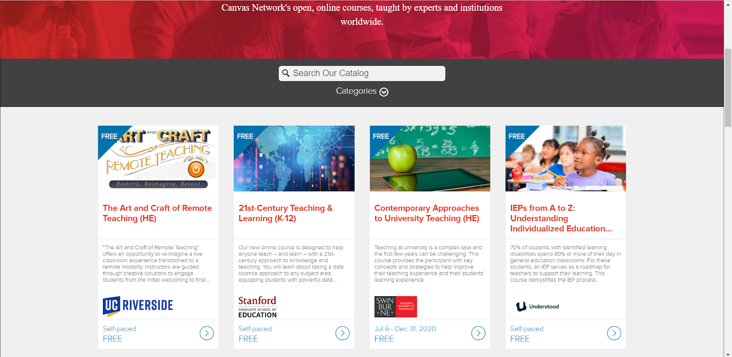

*Figure 2.1 Canvas*

**Blackboard** is another LMS out there and have gained quite popularity. Despite its wide uses, the accessibility of technology on blackboard is tough. Users hate the difficulty in navigating through the UI. They can’t understand how to use too many options or tools without a tutorial.

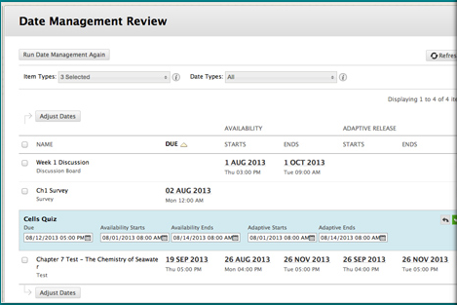

*Figure 2.2 Blackboard*

**Google classroom** is another example of LMS but it lacks key features. It is not much interactive and lacks integrated chat system as well as video conference.

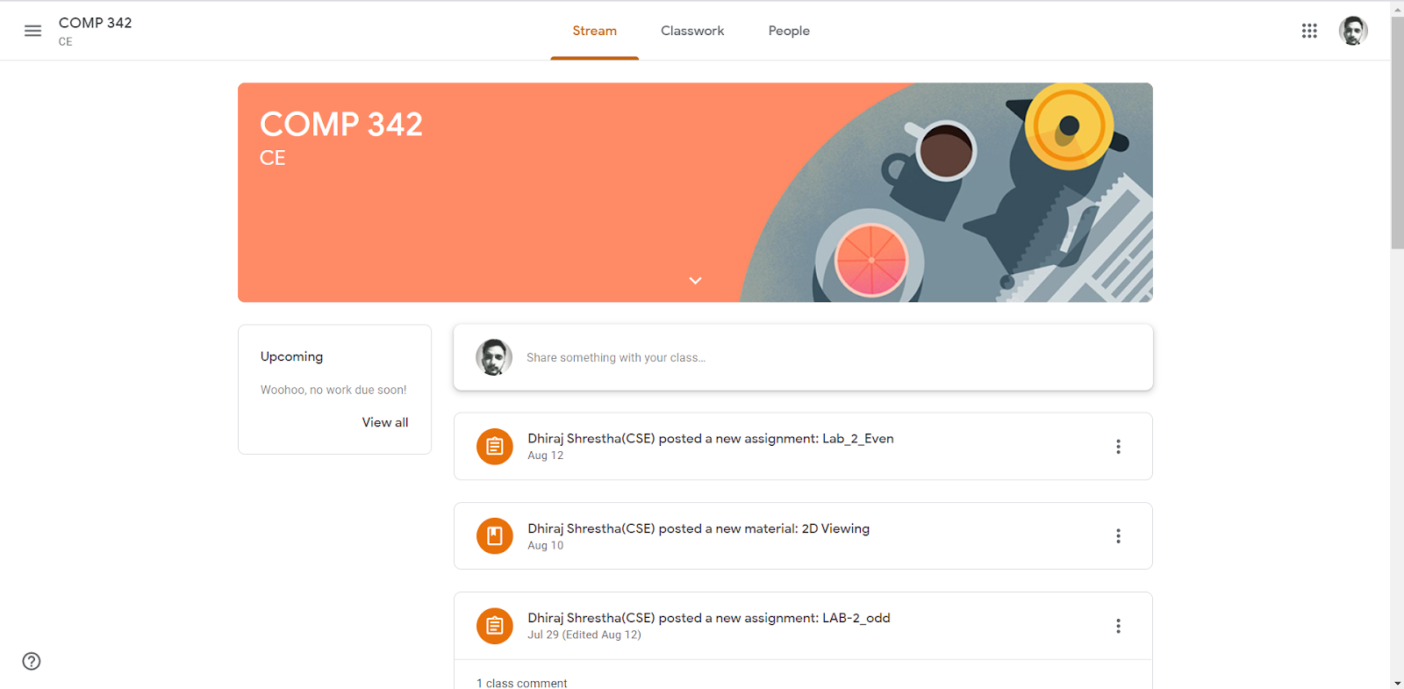

*Figure 2.3 Google Classroom*

Our designed application “My Virtual Classroom” provides access to students who may not be able to attend in-person courses. Through the virtual classroom environment, teachers can interact with students and students can engage with lesson materials, view presentations and videos, and take tests, all in real time. The classroom or the meeting room staple – whiteboard – remains intact. Brainstorming, ideation, and discussions happen in real-time. Tests are given and taken pre and post the session. Our application tried to solve all the problems these platforms have. Our application mainly targets the high school and college students and meets their demands.

# CHAPTER 3

# METHODOLOGY

# Design and Implementation

In order to complete a project successfully, certain steps and methods are to be followed strictly. While performing this project we strictly followed the design plans and implemented. Firstly, we made flow diagrams to analyses our project and work according to it. Then we deigned ER diagram for the database upon which our backend is based.

## 3.1 Flow Diagram

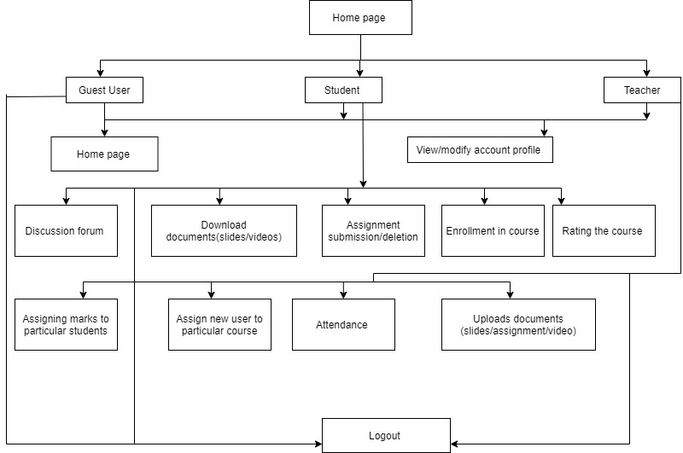

*Figure 3.1 Flow Diagram*

Guest users can visit the LMS and navigate to different courses provided in the landing page of LMS. Once a user logged in as a student, they are provided with the enrollment key to a particular subject. Then after the enrollment, they can download documents (lecture slides or videos), submit and delete assignments, rate the course, discuss the topic they prefer and many more. Similarly once a user is logged in as a teacher, they can update/edit their status, upload documents (assignments, lecture slides or videos) , assign a new user to a particular course, assign marks to individual students and log out of the system.

## 3.2 ER Diagram

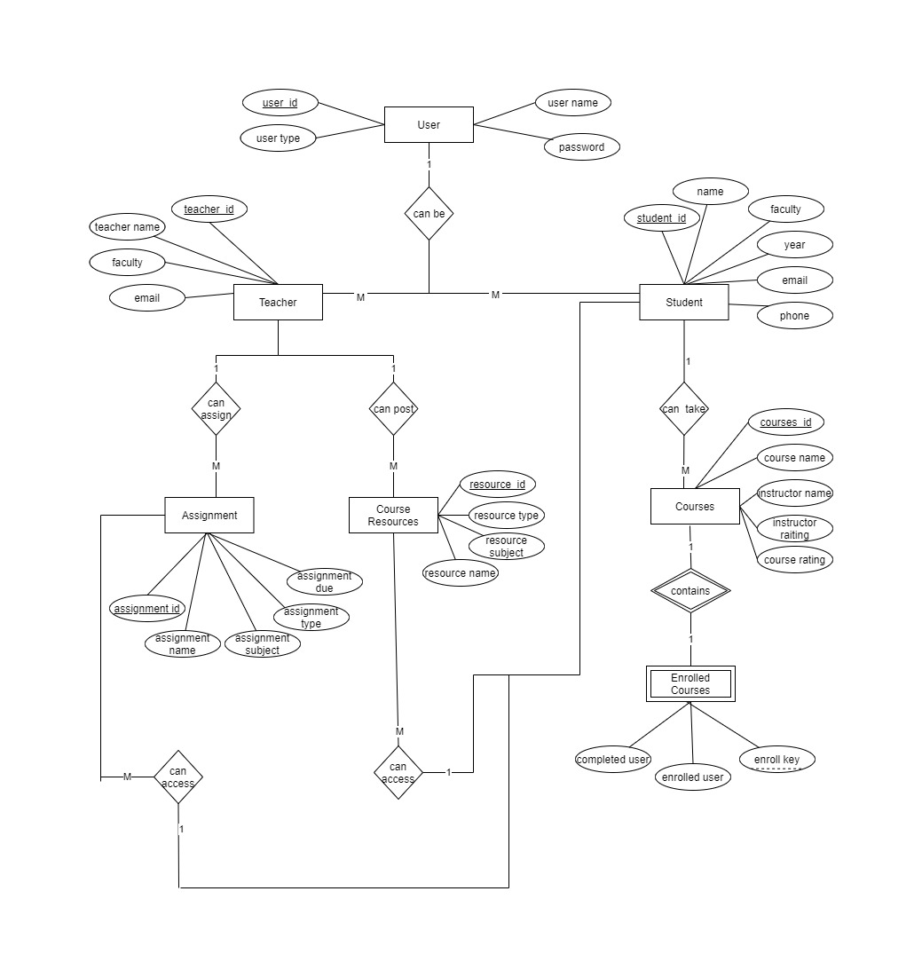

*Figure 3.2 ER diagram*

Our Project Contains two models for a user; one for student and one for teacher. From Teacher side, user can post assignment, any study resources (Course materials, Files, Text and even videos). From student side, users can enroll into any course with the enrollment key and they get access all the resources posted by teachers. In our project we have used id as the primary key for all the attributes. We have only one weak entity i.e. enrolled courses whose partial key is enroll key.

## 3.3 Use-case Diagram

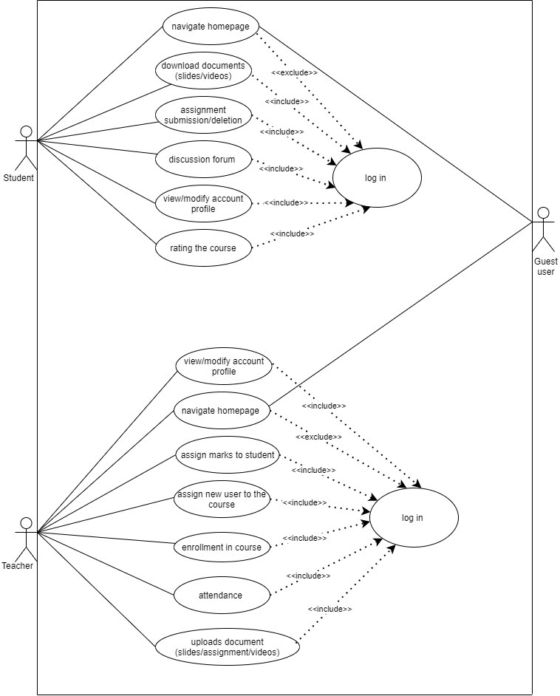

*Figure 3.3 Use-Case Diagram*

Guest users can visit the LMS and navigate to different courses provided in the landing page of LMS. Once a user logged in as a student, they are provided with the enrollment key to a particular subject. Then after the enrollment, they can download documents (lecture slides or videos), submit and delete assignments, rate the course, discuss the topic they prefer and many more. Similarly, once a user is logged in as a teacher, they can update/edit their status, upload documents (assignments, lecture slides or videos), assign a new user to a particular course, assign marks to individual students and log out of the system.

## 3.4 Procedure

### 3.4.1 Survey

Website experience surveys helps to improve user experience and create better website. We conducted the survey and gathered data of 70 stakeholder of our websites. Some of the results from the survey were:

* 70% users choose popup and hover card over dedicated webpages for all links

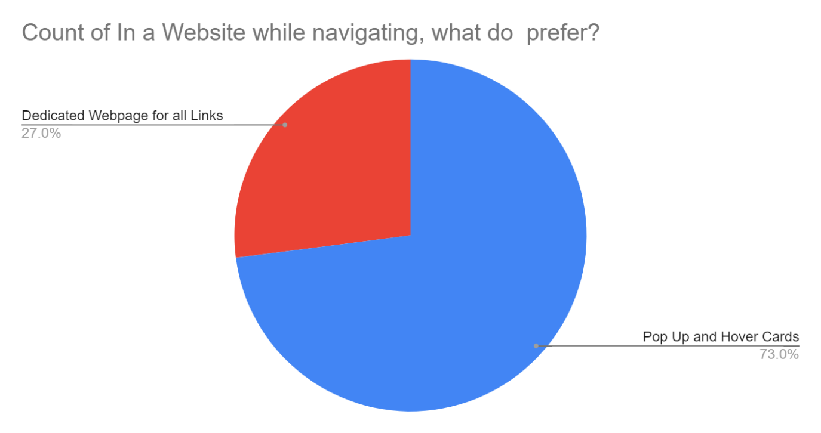

*Figure 3.4 Survey Chart 1*

* Nearly 61% users preferred rating of the course, 16% user doesn’t need it while 23% users were not sure

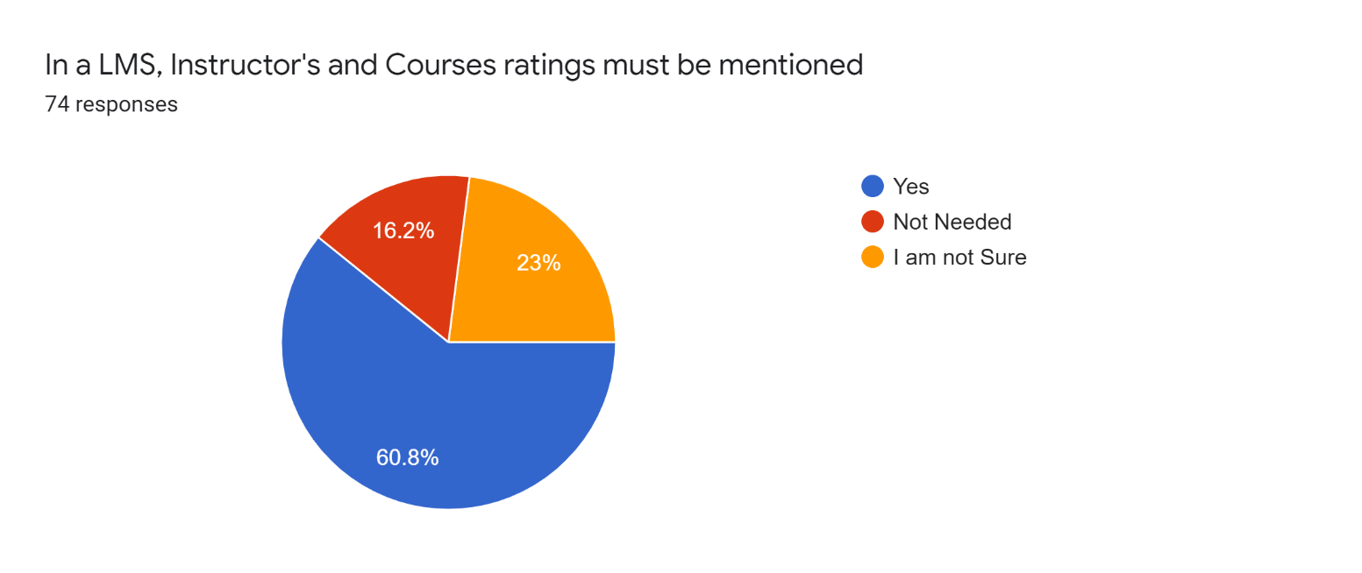

*Figure 3.5 Survey Chart 2*

* Most of user are feed up with the finding links and visiting it daily.

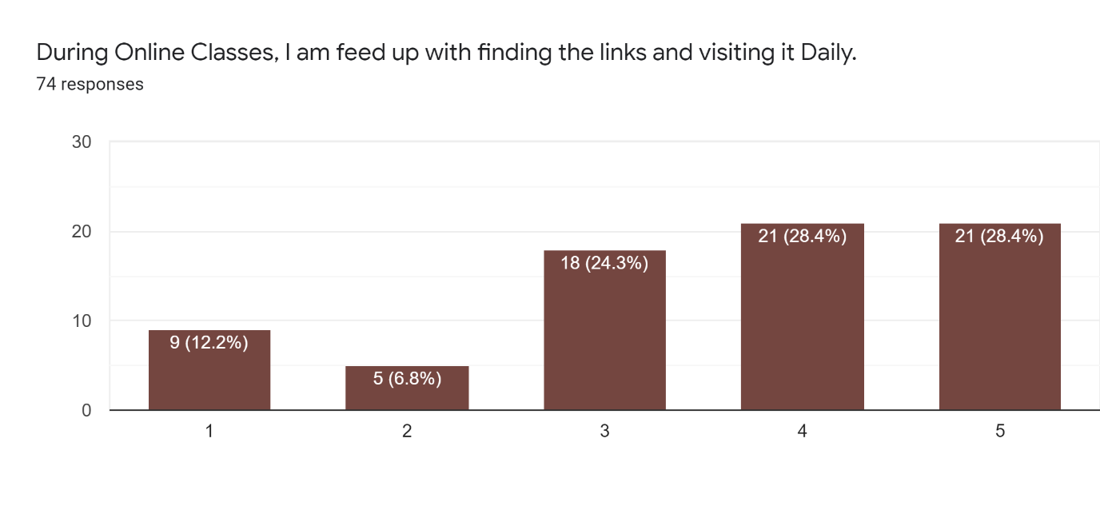

*Figure 3.6 Survey Chart 3*

* Most of the user demanded single and well managed page for assignment submission, course material, lecture videos and video conferences.

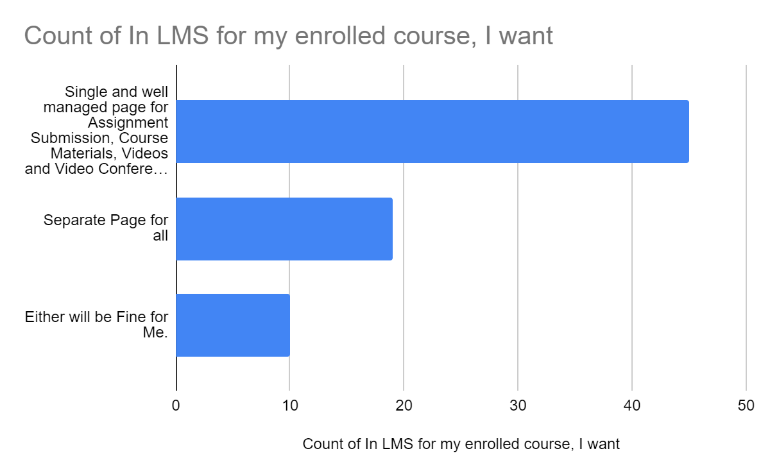

*Figure 3.7 Survey Chart 4*

### 3.4.2 Paper Prototype

Paper prototyping is a process where design teams create paper representations of digital products to help them realize concepts and test designs. We draw sketches and used them to guide our design and studied user’s reactions from the survey just conducted.

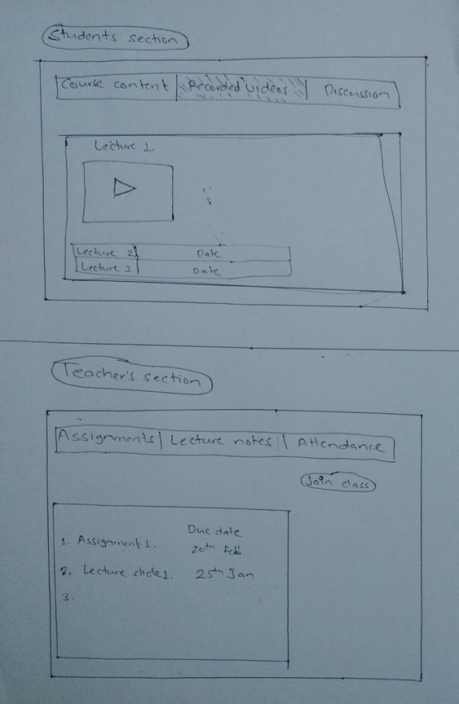

*Figure 3.8 Paper prototype for student and teacher*

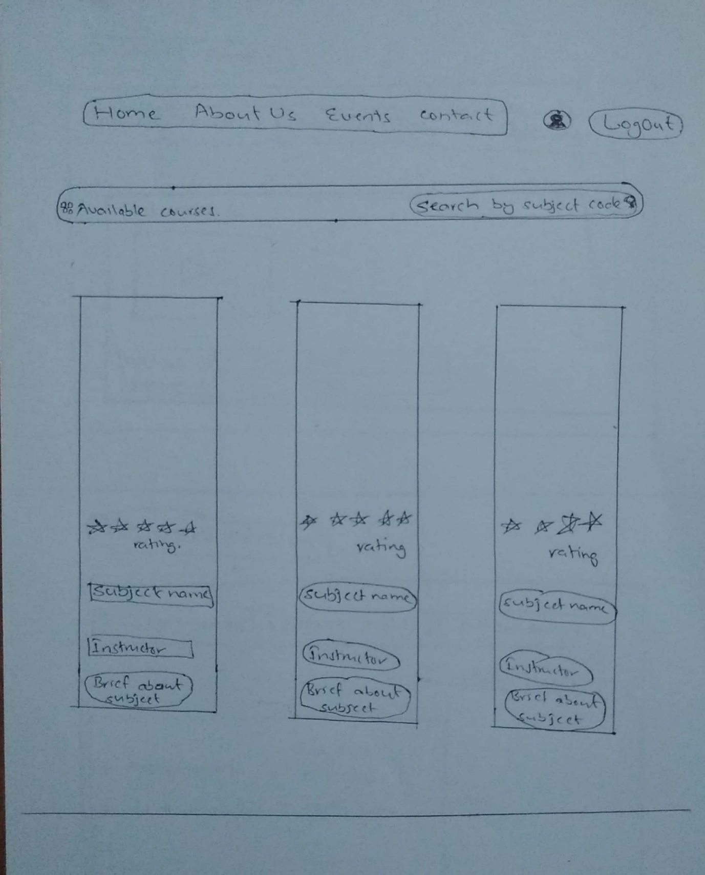

*Figure 3.9 Paper prototype for landing page of LMS*

As a usability testing technique: to observe the human interaction with user interfaces we created a paper prototype. It helps to communicate ideas between designers, developers, users and other stakeholders in the first stages of the user-centered design process. In figure 3.8 we designed a layout for students where they can get course content, recorded videos and discussion forum in a single webpage so that it reduces the burden of visiting different dedicated web pages for the task. Similarly, we also designed a prototype for teachers where they can upload assignments, lecture notes, join classes and take attendance in a single webpage. In figure 3.9 we designed the landing page of the LMS and worked on it later during the project.

### 3.4.3 Norman’s 7 principles

Norman's main idea is that devices, things, computers, and interfaces should be functional, easy to use, and intuitive. Based on Norman’s principles we developed our LMS on the basis of following points:

* Intuitive buttons and icon
* Constraints enrollment key
* Live chat to the right side of video
* Issues on online video conferencing and mapping between the pages

### 3.4.4 Schneiderman’s 8 Golden Rules

My Virtual Classroom provides users the sense that they are in full control of events occurring in the digital spaces. Using the Schneiderman’s 8 Golden rules we created great design, productive and frustration-free interfaces of LMS. Some of the key features are:

* Consistency- UI in same layout
* Functionality- shortcut features
* Feedback- logged in, enrolled, registration, task completion
* Usability of system- simple error messages
* Undo the action- edit, un-submit assignments

### 3.4.5 Heuristic evaluation

We established an appropriate list of heuristics using Nielsen and Moloch’s 10 heuristics. Evaluators were experts who have been using LMS for quite some time. There were two phases of evaluation. In the first phase of evaluation, the evaluators used the LMS freely to gain a feel for the methods of interaction and scope. Then they identified specific elements that they want to evaluate. In the second phase of interaction, the evaluators carried out another run-through, whilst applying the chosen heuristics to the identified during the first phase. The evaluators focused on the individual elements and look at how well they fit in the overall design.

### 3.4.6 Final Usability Testing

After the successful completion of designing and debugging now the LMS was undergone for final usability testing. We tested our LMS from different users and identified different issues in it and solved it accordingly.

# CHAPTER 4

# SYSTEM REQUIREMENT SPECIFICATIONS

## 4.1 Software Requirements

### 4.1.1 Visual Studio Code

Visual Studio Code is a [source-code editor](https://en.wikipedia.org/wiki/Source_code_editor) developed by Microsoft for Windows Linux and MacOS. It includes support for debugging, embedded [Git](https://en.wikipedia.org/wiki/Git) control, syntax highlighting, intelligent code completion, snippets, and code refactoring.

### 4.1.2 Google Chrome

Google Chrome is a web browser by Google. It is used to surfing internet. Here in this project we test our website in it.

### 4.1.4 Front End Tools

**A.HTML**

**HTML** stands for Hyper Text Markup Language. It is used to design web pages using markup language. HTML is the combination of Hypertext and Markup language. Hypertext defines the link between the web pages. Markup language is used to define the text document within tag which defines the structure of web pages. This language is used to annotate (make notes for the computer) text so that a machine can understand it and manipulate text accordingly. Most of markup (e.g. HTML) languages are human readable. Language uses tags to define what manipulation has to be done on the text.

**B. CSS**

**C**ascading **S**tyle **S**heets, fondly referred to as **CSS**, is a simply designed language intended to simplify the process of making web pages presentable. CSS allows you to apply styles to web pages. More importantly, CSS enables you to do this independent of the HTML that makes up each web page. CSS is easy to learn and understood but it provides powerful control over the presentation of an HTML document.

**C. JavaScript**

JavaScript is a scripting language most often used for client-side web development.

Client-side refers to operations that are performed by the client (in our case the client is the browser) in a client-server relationship.

**D. Bootstrap**

Bootstrap is a free and open-source CSS framework directed at responsive, mobile- first front-end web development. It contains CSS- and (optionally) JavaScript-based design templates for typography, forms, buttons, navigation and other interface components. Bootstrap is the third-most-starred project on GitHub, with more than 135,000 stars, behind only freeCodeCamp (almost 305,000 stars) and marginally behind Vue.js framework. According to Alexa Rank, Bootstrap getbootstrap.com is in the top-2000 in US while vuejs.org is in top-7000 in US.

**E. React.js**

React is a JavaScript library that aims to simplify development of visual interfaces. Developed at Facebook and released to the world in 2013, it drives some of the most widely used code in the world, powering Facebook and Instagram among many, many other software companies. Its primary goal is to make it easy to reason about an interface and its state in any point in time, by dividing the UI into a collection of components. React is used to build single-page web applications, along with many other libraries and frameworks that were available before React came into life.

### Back End Tools

1. **MYSQL**

MySQL is an Oracle-backed open source relational database management system (RDBMS) based on Structured Query Language (SQL). MySQL runs on virtually all platforms, including Linux, UNIX and Windows. Although it can be used in a wide range of applications, MySQL is most often associated with web applications and online publishing.

1. **Node.js**

Node.js is an open-source and cross-platform JavaScript runtime environment. It is a popular tool for almost any kind of project! Node.js runs the V8 JavaScript engine, the core of Google Chrome, outside of the browser. Node.js can leverage the work of the engineers that made (and continue to make) the Chrome JavaScript runtime blazing fast, and this allows Node.js to benefit from the substantial performance improvements and the Just-In-Time compilation that V8 performs.

1. **WebRTC**

WebRTC (Web Real-Time Communication) is a free, open-source project that provides web browsers and mobile applications with real-time communication (RTC) via simple application programming interfaces (APIs). It allows audio and video communication to work inside web pages by allowing direct peer-to-peer communication, eliminating the need to install plugins or download native apps. Supported by Apple, Google, Microsoft, Mozilla, and Opera, WebRTC is being standardized through the World Wide Web Consortium (W3C) and the Internet Engineering Task Force (IETF). Its mission is to "enable rich, high-quality RTC applications to be developed for the browser, mobile platforms, and IoT devices, and allow them all to communicate via a common set of protocols".

## 4.2 Hardware Requirements

Since our LMS is simple and lite, so we don’t require much complex hardware components. Any modern PC with internet access will be able to run our website.

# CHAPTER 5

# RESULTS, CONCLUSION AND FUTURE ENHANCEMENT

## 5.1 Results

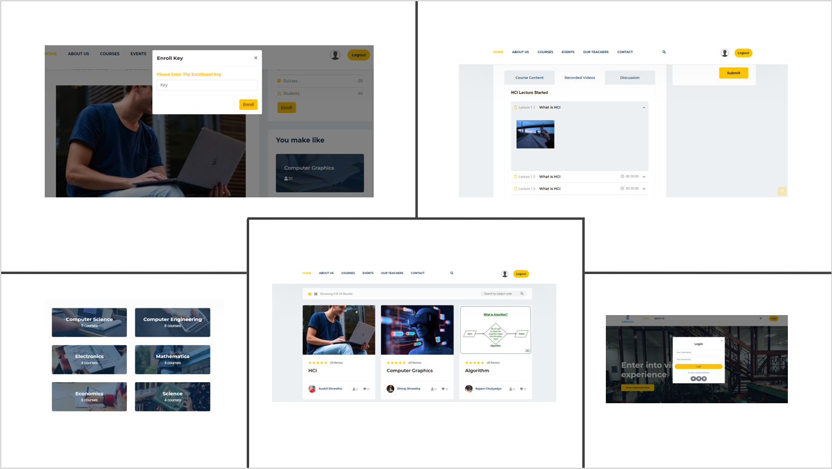

*Figure 5.1: Project Interface*

“My Virtual Classroom” was completed using different front end and backend tools.The project comprise of a landing page where a user can sign up or login. The landing page also give the gist of the total project. Other main features include courses sections where students could choose the courses based on their subject of interest and the teacher’s review.

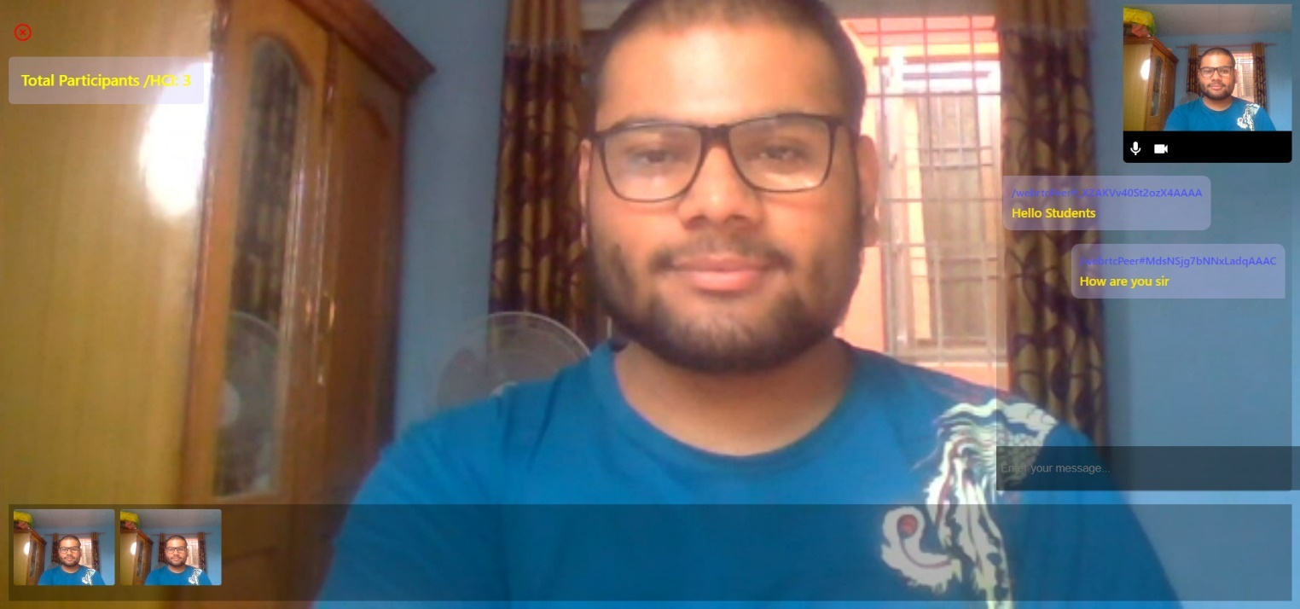

*Figure 5.2: Video Conferencing feature*

A video chatting feature was made using WebRTC principle where teacher can host the classroom and the students can join it to attain the class. A chat feature is made for better communication between the student and the teacher.

**

*Figure 5.3 Course Instructions*

After choosing the course student can enter the enrollment key and view the assignments and other resources provided by the teacher. There is a functionality to submit the assignment provided by the teacher in due time. On the same particular page student can enter into the classroom according to their schedule. Alongside this, there is news portion where student can know about the ongoing activities around their institution.

## 5.2 Conclusion

After the Competition of our project, we are extremely satisfied with the result. We have come up with one of the most usable LMS. During this journey starting from survey and ending to usability testing, we have always listened to the users of LMS and built it accordingly. Hence, we think “My Virtual Classroom” will solve out all the problems that the users of LMS have been facing and we are proud to have given it birth. This project has taught us many skills that we will surely come handy in future. Overall, the experience building “My Virtual Classroom” was beautiful and satisfying.

## 5.3 Limitations

Despite of the efforts to make the project perfect, there were still some limitations which are listed as follows:

### For the automatic video recording and uploading, we need to implement a machine learning algorithm so we dropped that for now and planned to implement it in future.

### Due to the time constraint, the in-built drawing tool for tutor was discontinued.

### We introduced the live texting during video conferencing and left the additional features like hand raising. We were more confined to the usability of the LMS.

## 5.4 Future Enhancements

We are planning to add these features to our LMS:

1. **Automatic video recording and uploading.**

To make our LMS easier to use, we intend to develop automatic video recording and uploading after the course is finished. It will save a lot of effort of the administrator to record & upload.

1. **In-built drawing tool for the tutor.**

It will be easy for the tutor if there was in built drawing tool during the video conferencing to clearly define their point.

1. **Features like hand raising.**

Features like hand raising will maintain discipline and contribute a lot while asking query of students.

# BIBLIOGRAPHY

[1] Wikipedia Contributors, “JavaScript,” Wikipedia, 18-Apr-2019. [Online]. Available:

https://en.wikipedia.org/wiki/JavaScript.

[2] tutorialspoint.com, “Node.js Introduction,” www.tutorialspoint.com, 2009. [Online].

Available: https://www.tutorialspoint.com/nodejs/nodejs_introduction.htm.

[3] Wikipedia Contributors, “HTML,” Wikipedia, 13-Mar-2019. [Online]. Available:

https://en.wikipedia.org/wiki/HTML.

[4] “React – A JavaScript library for building user interfaces,” Reactjs.org, 2019. [Online].

Available: https://reactjs.org/.

[5] Wikipedia Contributors, “Website,” Wikipedia, 01-Apr-2019. [Online]. Available:

https://en.wikipedia.org/wiki/Website.

# APPENDIX (GANTT CHART)

|  |  |  |  |  |  |  |  |  |  |  |  |  |  |  |  |
| --- | --- | --- | --- | --- | --- | --- | --- | --- | --- | --- | --- | --- | --- | --- | --- |
| Months | June | | | July | | | | August | | | | September | | | |
| Weeks | 2 | 3 | 4 | 1 | 2 | 3 | 4 | 1 | 2 | 3 | 4 | 1 | 2 | 3 | 4 |
| Planning/Proposal Submission |  |  |  |  |  |  |  |  |  |  |  |  |  |  |  |
| Preparation |  |  |  |  |  |  |  |  |  |  |  |  |  |  |  |
| Work Division |  |  |  |  |  |  |  |  |  |  |  |  |  |  |  |
| Coding |  |  |  |  |  |  |  |  |  |  |  |  |  |  |  |
| Debugging |  |  |  |  |  |  |  |  |  |  |  |  |  |  |  |
| Documentation |  |  |  |  |  |  |  |  |  |  |  |  |  |  |  |
| Beta Testing |  |  |  |  |  |  |  |  |  |  |  |  |  |  |  |

|  |  |
| --- | --- |
|  | Work Completed |
|  | Work Remaining |

*Figure A.1: Gantt Chart*